Niagara Bottling: Are Price Promotions Cannibalistic?

Deekshitha Balaji (deekshitha.balaji@gatech.edu)
Vivek Sagi (vivek.sagi@gatech.edu)
Abhijeet Deo (adeo36@gatech.edu)

The Georgia Institute of Technology
MGT 6746 Applied Analytics Practicum
Dr. Joel Sokol
June 17th, 2026

Table of Contents
Right-click here and choose “Update Field” to generate the Table of Contents.

Introduction and Objective
Niagara Bottling, LLC. is a beverage manufacturer that was founded in Irvine, California in 1963 by Andrew Peykoff Sr (Niagara Bottling, LLC, n.d.). Their product offerings include purified water, spring water, distilled water, infant water, alkaline water, sparkling water, aseptic, vitamin enhanced waters, and tea (Niagara Bottling, LLC, n.d.). Due to the diversity of Niagara’s product mix and large scale of its operations, it is crucial to evaluate potential promotions using a comprehensive data-driven framework. Promotions that boost an individual SKU’s sales, while simultaneously pulling demand away from other products in the same portfolio are considered cannibalistic. The primary objective of this project is to provide Niagara a scalable data analytics pipeline to identify incremental price promotions. Specifically, a pipeline that includes data visualizations and actionable recommendations pertaining to the business questions outlined in a subsequent section.

Exploratory Data Analysis
The purpose of this section is to analyze the dataset structurally and visually to derive insights about how to build the cannibalization models in a subsequent section. The sponsor has provided 19 csv source files and a data dictionary of each attribute. For subsequent processing and analysis purposes, the source files will be combined into a single dataframe. The merged dataframe has 82 columns and 162,965 observations. As a starting point, the distribution of the response variable “units” reveals that there are many observations without any sales volume, causing a skewed shape. This may later dictate whether certain observations should be handled separately than those with non-zero sales volume. The rank-size distribution plots of sales volume by SKU and Brand show that the “WATER” category comprises 800+ SKUs and 100+ brands. More importantly, the long-tailed shape of both plots illustrates that a small number of SKUs and brands dominate the category’s sales volume. It is plausible that price promotions on the specific SKUs or brands dominating the category are more likely to impact category incrementality. Next, the time-series plot of sales volume indicates that sales for this category spike in the summer months and gradually decline from September onwards. Nevertheless, seasonality and holiday predictors will be explicitly included in subsequent model(s) to take those effects into account. The histograms of “prc_acv” and “tpr_discount” show that both distributions are positively skewed. This implies that product distribution for many SKUs in this category is limited on most weeks and discounts are infrequent. Interestingly, the balanced distribution of the “competitor_promo_count” bar graph reveals that promotional activity is consistent in this category with 220+ SKUs being promoted each week. This finding reinforces the earlier rank-size distribution plot by SKU where roughly 20% of SKUs dominate the category! Presumably, these 20% of “critical” SKUs are the ones amongst which promotional activity is active. Lastly, the boxplots show that distributions vary significantly for the “price_promo” and “outer_pack_size” predictors. It is plausible that those predictors will significantly impact cannibalization in subsequent models. Conversely, the distributions for the “seasonality_peak_flag” and “holiday_clubbed” predictors do not vary significantly. It will be interesting to observe whether these predictors exhibit high p-values in subsequent models. Please refer to the figures below for a visual representation of the data insights presented in this section:
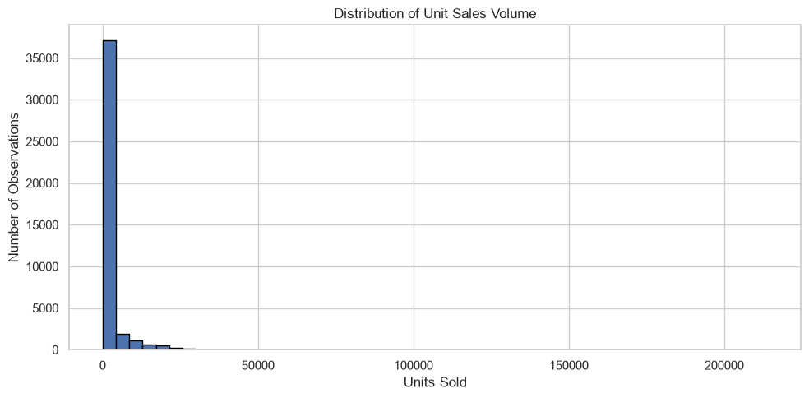
Figure 1: Response Variable Distribution
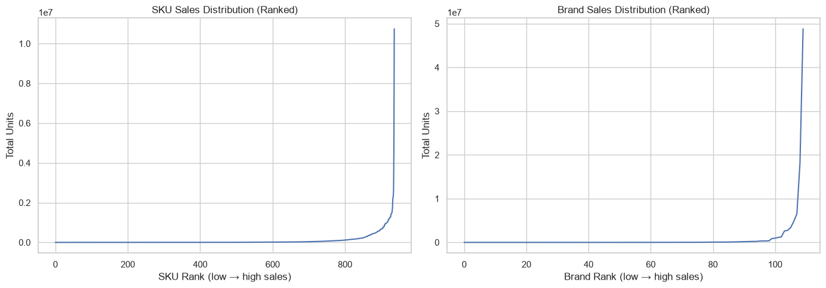
Figure 2: SKU and Brand Distribution
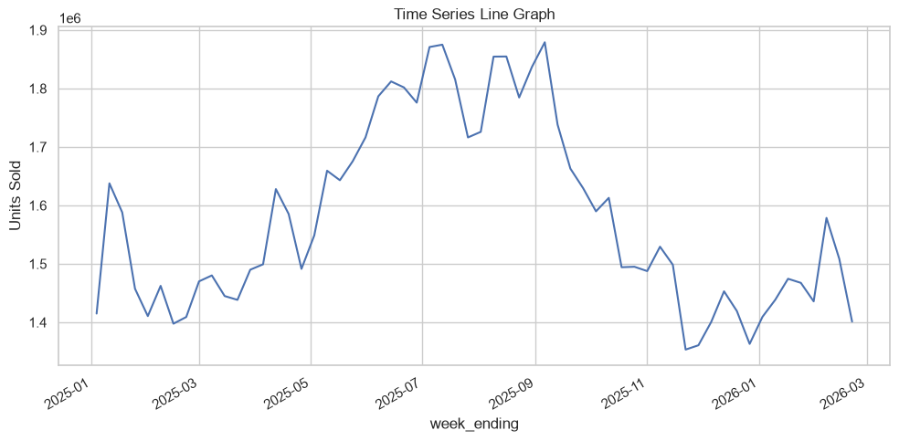
Figure 3: Time-series plot
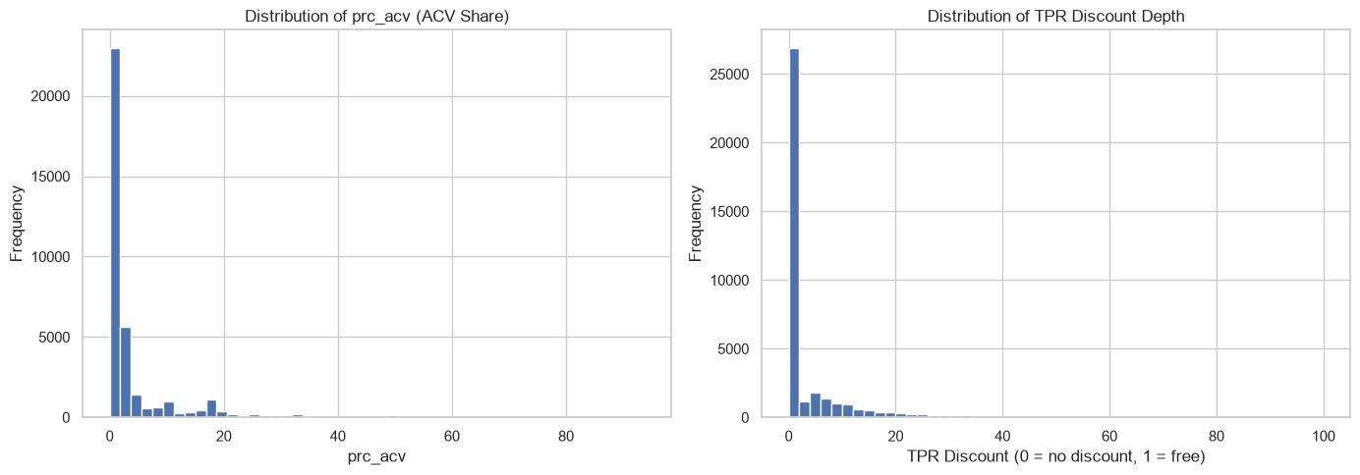
Figure 4: prc_acv and tpr_discount frequency distributions
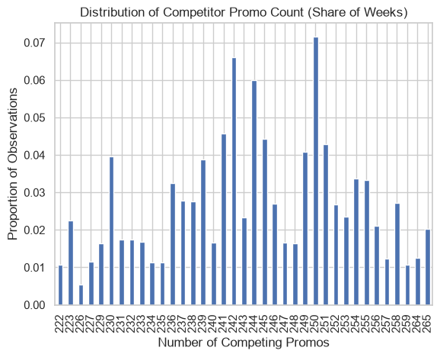
Figure 5: Competitor promotional activity distribution
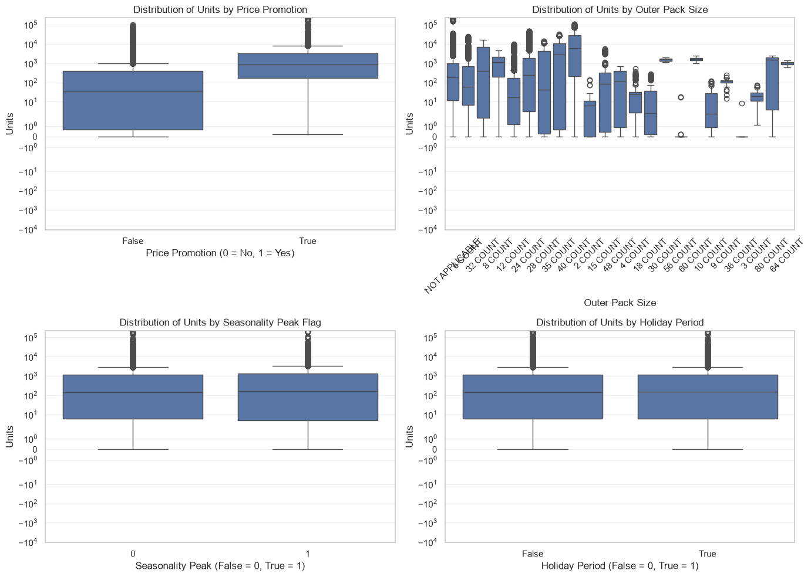
Figure 6: Boxplots for relevant categorical or binary predictors
A scope note on this section: the exploratory analysis above, and Figures 1–6, were run on the raw “category == ‘WATER’” filter (937 SKUs, 110+ brands), before the sponsor’s niagara_personal_chars segment tag was cross-checked against the raw category field. As described in the Methods section, that check found the “WATER” category captures 99.7% of SUW rows but less than 0.3% of SFW rows — SFW volume is tagged almost entirely under “VALUE ADD WATER” instead. The directional insights here (right-skewed, long-tailed sales concentration; summer seasonality; infrequent but consistent promotional activity) still held up and informed the modeling approach, but the specific SKU and brand counts, and the underlying figures, reflect the pre-correction WATER-only universe rather than the corrected 1,903-SKU, 237-brand SUW + SFW scope used from the Methods section onward.

Assumptions
The following assumptions will be made for the subsequent sections to build a functional, proof-of-concept pipeline:
1) Focus on the still-water segments only — Still Unflavored Water (SUW) and Still Flavored Water (SFW) — identified via the sponsor’s niagara_personal_chars segment tag rather than the raw “category” field, since SFW volume is tagged almost entirely under “VALUE ADD WATER” rather than “WATER” (all brands)
2) Single region only (all brands)
3) Focus on pure price-discount promotions only i.e. exclude feature and display promotions
The future scaling of the pipeline across other product categories will be addressed in the “Conclusions and Future Work” section.

Business Questions
The sponsor, Niagara Bottling is interested in obtaining insights and actionable recommendations about the high-level and factor-specific business questions delineated below:

High-level:
- Are price promotions truly incremental to the overall category, or is volume being shifted between SKUs in the portfolio?

Factor-specific:
- Does promoting one SKU decrease sales for similar or adjacent SKUs?
- What patterns or signals indicate cannibalization risk?
- Are certain product types (pack sizes, sub-brands) more cross-sensitive?
- How does promo timing or discount depth influence interactions?
- What future models could measure cannibalization at scale?

Methods
Building on the assumptions outlined above, the initial WATER-only scope was refined after closer inspection of the sponsor-provided segment tag, “niagara_personal_chars,” which classifies every row as “PC_Total SUW” (Still Unflavored Water) or “PC_Total SFW” (Still Flavored Water) independent of the raw “category” field. Cross-tabulating segment against category revealed that SFW volume is tagged almost entirely under “VALUE ADD WATER” rather than “WATER” — filtering on category == “WATER” alone therefore captured 99.7% of SUW rows but less than 0.3% of SFW rows, effectively excluding the flavored-water segment from the pipeline. The modeling universe was consequently redefined as category-independent: any row tagged “PC_Total SUW” or “PC_Total SFW,” spanning both the “WATER” and “VALUE ADD WATER” raw categories. This expanded the pipeline from 41,983 rows / 937 SKUs to 82,458 rows / 1,903 SKUs across 237 brands, and SUW and SFW are treated as separate segments throughout the remaining methodology, consistent with sponsor guidance that substitution behavior is likely stronger within a segment than across segments.
Pure price-discount promo weeks are classified using the ACV decomposition provided in the source data: a SKU-week is flagged “pure_price_promo” when promo_flag == 1, a temporary price cut occurred (tpr_discount > 0), and price_decr_only_prc_acv accounts for the majority of any_promo_prc_acv, i.e., feature or display support was not the dominant promotional mechanism that week. Applying this rule to the combined SUW + SFW universe classifies 16.6% of SKU-weeks as pure price-discount promotions, with SFW promoting nearly twice as frequently as SUW (25.4% vs. 13.5% of SKU-weeks).
A SKU-level baseline is established with a log-linear ordinary least squares (OLS) regression of log(units) on SKU fixed effects, the sponsor-provided seasonality index, tpr_discount, and major U.S. holiday indicators, fit on non-promo weeks only and restricted to the 1,474 SKUs with at least 20 weeks of observation. Predicted baseline units are then compared against actual units in every week to derive each SKU’s own lift and lift percentage. Own-price elasticity is estimated with a companion log-linear OLS model of log(units) on SKU fixed effects, log(price), and the seasonality index. Because a single ordinary least squares estimate can be sensitive to the heavy-tailed, right-skewed sales distribution already noted in the exploratory analysis, two additional statistical methods are layered onto the elasticity model and the cross-SKU signal model described below: robust regression using Huber’s T norm, which down-weights outlier SKU-weeks, and quantile (median) regression, which estimates the response at the conditional median rather than the mean. Both are fit on a “within” (SKU-demeaned) transformation of the data, which is algebraically equivalent to including SKU fixed effects directly but keeps the design matrix tractable for the iterative solvers these two estimators require.
Cannibalization is evaluated within segment first, consistent with the sponsor’s guidance that SUW and SFW substitution is likely stronger within a segment than across segments. Because pack_type alone only takes three values across roughly 1,900 SKUs, substitute groups are instead defined by segment, brand, base pack size, and pack type — the combination of attributes closest to how a shopper would compare products at shelf. Two alternate hierarchies are also constructed and compared for coverage: a cross-brand grouping (segment, size, pack type) that tests substitution across competing brands of similar size, and a cross-size grouping (segment, brand, pack type) that tests substitution within a brand across pack sizes, per the sponsor’s request to test multiple comparison groups rather than assume a single, fixed hierarchy.
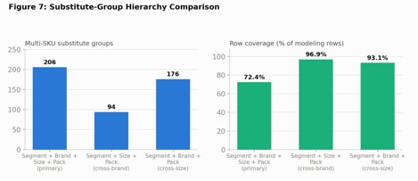
Figure 7: Substitute-Group Hierarchy Comparison
For every meaningful promo event (own lift of at least 10% above baseline, within a substitute group of two or more SKUs), a cannibalization rate is computed as the negative ratio of the promoted SKU’s substitute group’s net volume change to the promoted SKU’s own lift, excluding any peer that is simultaneously running its own price promotion. A rate of zero indicates a fully incremental promotion, a rate of one indicates full cannibalization within the group, and a negative rate indicates a halo effect in which peers also gain volume. Because this ratio is a function of two noisy quantities, the median and an aggregate (volume-weighted) rate are reported as the primary statistics rather than the mean. Cannibalization is calculated first at the SKU/UPC level and then rolled up to brand and segment. Recognizing that the sponsor’s dataset reflects observed rather than guaranteed unconstrained demand, each SKU-week is also screened for a pattern consistent with a stockout or supply disruption — a sharp drop relative to the SKU’s own trailing four-week average in a non-promo week, immediately followed by a rebound — and the share of a promo event’s peer-weeks carrying this flag is retained as a caveat on, rather than a filter applied to, the cannibalization results.
Finally, the cannibalization signal is validated with two non-parametric tests that are robust to the heavy-tailed rate distribution: a sign test on whether peer SKUs lose net volume more often than the 50% expected by chance during focal-SKU promo weeks, and a Wilcoxon signed-rank test of whether the median cannibalization rate differs from zero. Both tests are re-run after excluding events with a stockout-flagged peer-week, as a sensitivity check on whether the result is being driven by the observed-demand limitation described above.
A final extension tests whether the cross-SKU effect itself, not just the baseline lift, differs by product type, sub-brand, discount depth, or timing. Section 7's cross-SKU model estimates a single, pooled effect and cannot say whose cross-sensitivity is different, so we interact promo_intensity with pack_type, a base-size tercile bucket, the top eight brands by volume (smaller brands pooled into “Other”), the average discount depth among a substitute group's promoted SKUs that week, and calendar quarter and holiday-week flags, on the same group-week panel used in Section 7. Each interaction is fit in isolation, then all together in a combined model with cluster-robust standard errors (clustered by substitute group, since weeks within a group are not independent observations) and cross-checked against Huber's T robust regression, following the same OLS-vs-robust comparison used in Sections 6.1 and 7.1.

Analysis and Results
Applying the segment-first scope described in the Methods section nearly doubled the modeling universe relative to the original WATER-only assumption, from 41,983 rows and 937 SKUs to 82,458 rows and 1,903 SKUs (1,350 SUW and 553 SFW) across 237 brands. SFW accounts for a modest but non-negligible 9.2% of still-water sales and promotes considerably more often than SUW (25.4% vs. 13.5% of SKU-weeks), underscoring that the original scope would have drawn any flavored-water conclusion from fewer than 60 rows.
The baseline log-linear model, fit on 58,259 non-promo SKU-weeks, explains 93.5% of the variance in log(units) (R² = 0.935), and residual diagnostics (linearity, constant variance, and normality checks) do not reveal material departures from OLS assumptions beyond the heavier tails expected around promo-adjacent weeks. Please refer to the figures below illustrating that the OLS model diagnostics:
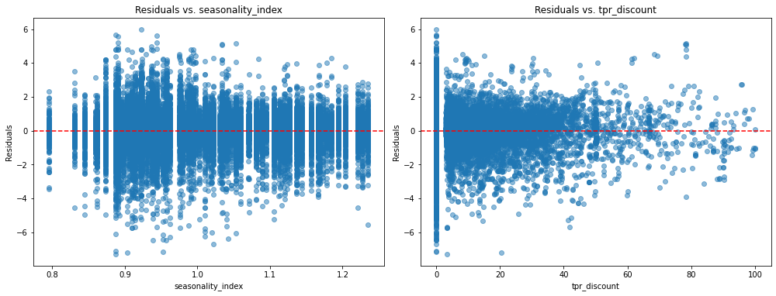
Figure 8: Linearity Check - Baseline Model
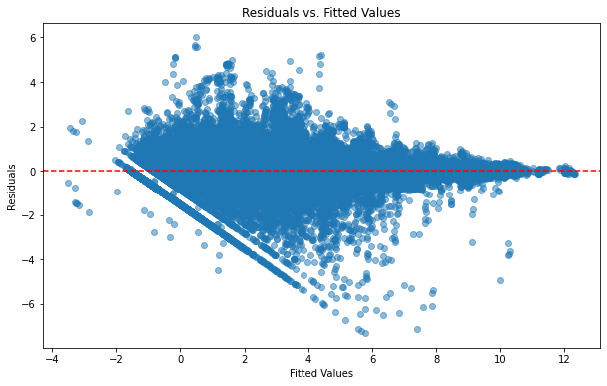
Figure 9: Constant Variance and Uncorrelated Errors Check - Baseline Model
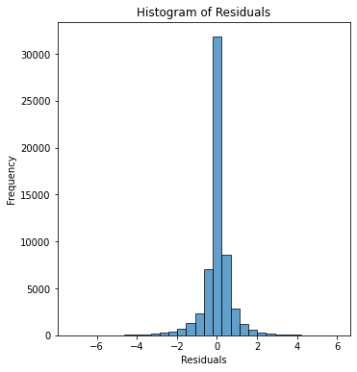
Figure 10: Histogram Normality Check - Baseline Model
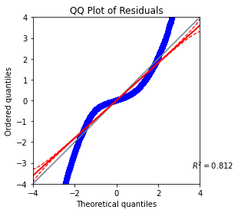
Figure 11: QQ Plot Normality Check - Baseline Model
The companion own-price elasticity model estimates an average own-price elasticity of -0.318 (p < 0.0001) across the 1,474 eligible SKUs — own-SKU units rise as price falls, and the magnitude is larger than the -0.121 estimate from the original WATER-only pipeline because SFW SKUs, which promote more frequently and at deeper discounts, are now included. Comparing estimation methods on the same within-SKU (demeaned) specification shows the sign and significance of this relationship are consistent across OLS (-0.318), Huber’s T robust regression (-0.723), and median (quantile) regression (-0.814); all three reject a null elasticity at p < 0.0001, but the substantially larger robust and quantile estimates indicate the SKU-level price response is right-skewed, i.e., a subset of highly price-responsive SKUs pulls the median-based estimates further from zero than the mean-based OLS estimate.
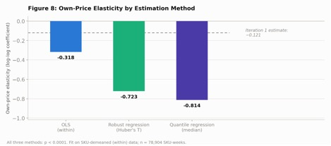
Figure 12: Own-Price Elasticity by Estimation Method
The primary substitute-group hierarchy (segment, brand, base size, pack type) yields 617 groups, of which 206 contain two or more SKUs and cover 72.4% of modeling rows. The two alternate hierarchies tested for sensitivity cover a larger share of rows at a coarser definition of substitution — the cross-brand hierarchy (segment, size, pack type) covers 96.9% of rows across 94 multi-SKU groups, and the cross-size hierarchy (segment, brand, pack type) covers 93.1% of rows across 176 multi-SKU groups — confirming that the primary hierarchy is the most conservative, shelf-realistic definition of a substitute and supporting its use as the basis for the SKU-level cannibalization calculation.
At the substitute-group level, a panel regression of group-level lift on promo intensity is positive and highly significant under all three estimation methods (OLS coefficient of 1.09, Huber’s T robust regression coefficient of 0.35, median regression coefficient of 0.30; all p < 0.0001), indicating that a substitute group tends to gain, not lose, volume as promo intensity within it rises — a halo rather than a cannibalization signal — though OLS’s substantially larger coefficient shows its mean-based estimate is inflated by a handful of very large positive outlier weeks relative to the more representative robust and median estimates. Consistent with this, the SKU-level cannibalization-rate calculation across 5,342 qualifying promo events returns a median rate of -0.10 (a mild halo effect), with 60.8% of events showing peers gaining net volume (halo), 23.6% showing partial cannibalization, and 15.6% showing full or over-cannibalization. Rolling these events up to the segment level shows SFW carries a stronger median halo effect than SUW (-0.18 vs. -0.04), while SUW’s aggregate, volume-weighted rate is more negative than SFW’s (-4.38 vs. -1.66) because a small number of high-volume SUW substitute groups, notably Private Label, dominate the aggregate figure — reinforcing the choice of the median as the primary summary statistic.
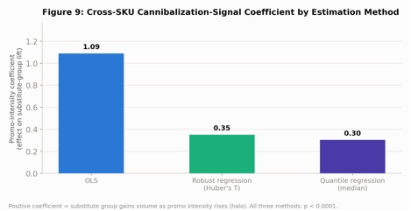
Figure 13: Cross-SKU Cannibalization-Signal Coefficient by Estimation Method
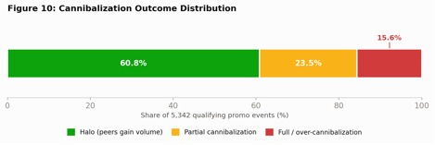
Figure 14: Cannibalization Outcome Distribution
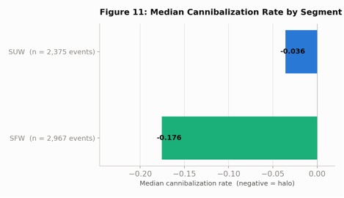
Figure 15: Median Cannibalization Rate by Segment
4.4% of modeling rows exhibit a pattern consistent with a possible stockout or supply disruption (a sharp drop from the trailing average followed by a rebound), similarly distributed across SUW (4.3%) and SFW (4.7%). This pattern touches at least one peer-week in 32.8% of cannibalization events; excluding those events as a sensitivity check leaves the result essentially unchanged (33.1% of the remaining events show peers losing net volume, versus 33.7% overall, with a median rate of -0.067 versus -0.102), indicating the headline signal is not an artifact of the observed-demand limitation in the data. Formal statistical validation confirms the signal is real: peers lose net volume in only 33.7% of events, significantly less than the 50% expected by chance (sign test p < 0.0001), and a Wilcoxon signed-rank test rejects a median cannibalization rate of zero (p < 0.0001).
Extending the cross-SKU model with interaction terms (Section 11 of the notebook) answers the two business questions left open by the original scope: whether certain product types are more cross-sensitive, and whether promo timing or discount depth changes the interaction. In the combined model (n = 11,719, R² = 0.073), plain OLS finds no interaction term significant at p < 0.05 — but Huber's T robust regression finds four: discount depth (coefficient 0.043, p < 0.0001), the Q3 and Q4 seasonal quarters (coefficients 0.094 and 0.061, p = 0.0005 and 0.033), and medium- vs. small-base-size substitute groups (coefficient 0.088, p = 0.0006). This is the same pattern already seen in the elasticity and cross-SKU signal models (Sections 6.1, 7.1): a handful of extreme group-weeks inflate OLS's coefficients into a wide, noisy range while masking smaller, genuine effects that the outlier-resistant robust fit recovers.
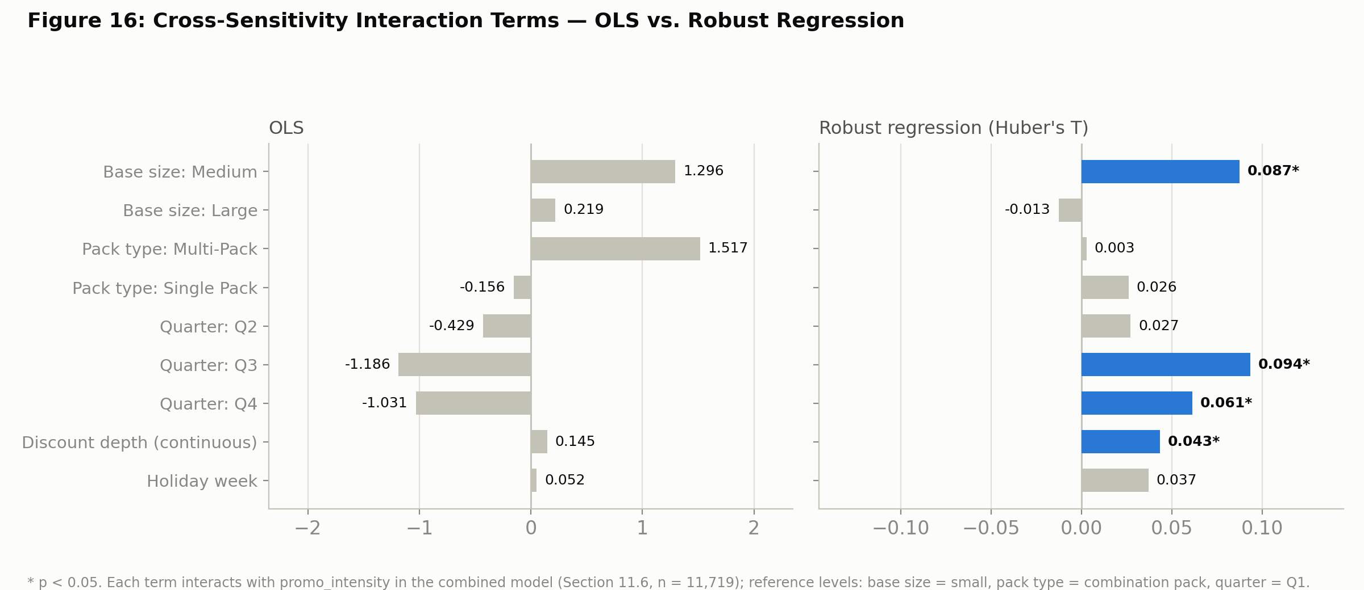
Figure 16: Cross-Sensitivity Interaction Terms — OLS vs. Robust Regression
The discount-depth interaction is the clearest and most actionable of the four: deeper discounts are associated with a larger, more positive group-level lift, not just a bigger promoted-SKU lift. The raw pattern is monotonic — mean group_lift_pct rises from 0.28 in group-weeks with no promo, to 0.30 for shallow discounts, 0.50 for medium discounts, and 1.46 for deep discounts — consistent with the modeled interaction coefficient, and suggesting that deeper price cuts widen the halo (or, at the tail, could begin tipping some substitute groups toward cannibalization) rather than simply scaling the existing effect up uniformly.
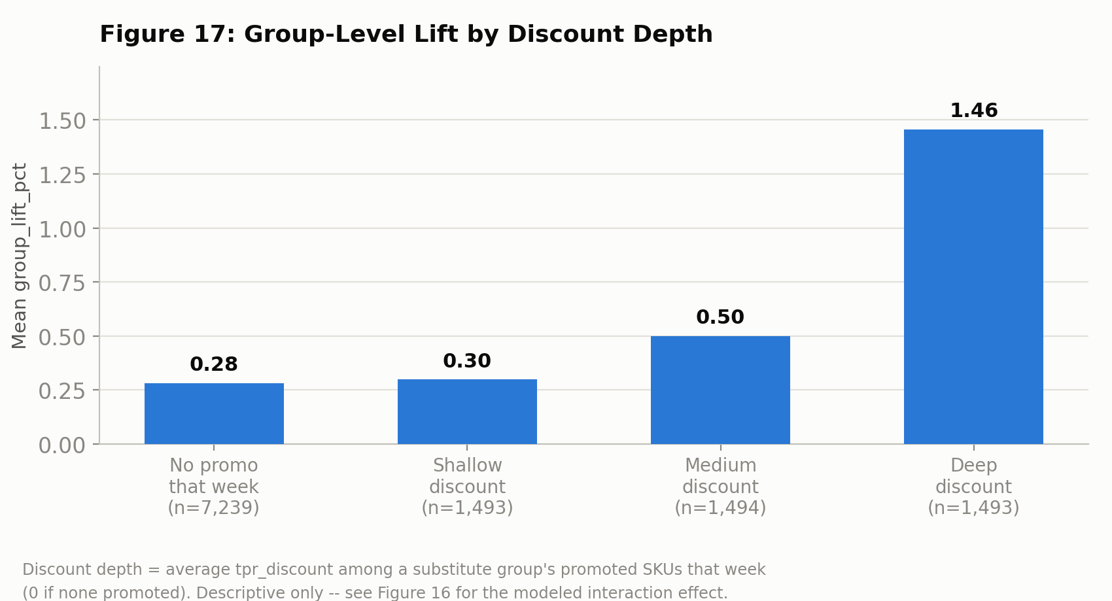
Figure 17: Group-Level Lift by Discount Depth
The seasonal (Q3/Q4) and base-size interactions are directionally real under the robust fit but should be read cautiously: discount depth, quarter, and holiday timing are correlated (deeper discounts cluster in certain quarters), so any single interaction coefficient is less trustworthy in isolation than the combined-model read. Pack type, individual sub-brand, and holiday-week status were not significant in the combined model under either method — an isolated brand-only model did find “Other” (pooled smaller brands) and Private Label showing a significantly stronger promo response, but that significance did not survive once discount depth, size, and timing were netted out, suggesting it was a proxy for those other factors rather than a true brand effect. Net of everything else, we do not find evidence that pack type or individual sub-brand systematically change the cross-SKU cannibalization/halo response in this dataset.

Actionable Recommendations
Based on the pipeline results presented in the prior section, Niagara’s price-discount promotions on still water appear predominantly incremental rather than self-cannibalizing, but the following actionable recommendations are proposed to manage the meaningful minority of cannibalization risk and to operationalize the pipeline for ongoing use:
1) Continue pure price-discount promotions as a broadly safe lever for the still-water category: 60.8% of qualifying promo events show a halo effect and the aggregate and median cannibalization rates are negative, and this conclusion is statistically significant (sign test and Wilcoxon p < 0.0001) and stable across SUW, SFW, and three estimation methods.
2) Do not treat “promotions are safe” as a blanket rule: roughly 39% of promo events show partial or full cannibalization. Category Management should use the SKU- and brand-level detail exported from the pipeline to flag and review specific high-cannibalization-risk SKU, brand, and pack-size combinations before approving future promotions on them.
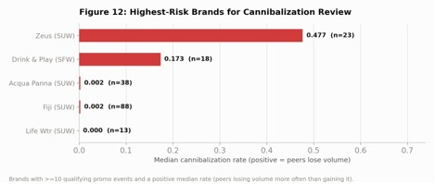
Figure 18: Highest-Risk Brands for Cannibalization Review
3) Manage SUW and SFW as distinct promotional strategies rather than a single blended “WATER” policy: SFW promotes nearly twice as often as SUW, contributes disproportionately to the pooled own-price elasticity estimate, and shows a stronger median halo effect, suggesting flavored-water promotions may currently be under- or well-calibrated in ways a single category-wide rule would miss.
4) When sizing the expected impact of a specific promotion, do not rely on a single point estimate: the substantial divergence between the OLS estimate and the robust/quantile estimates for both own-price elasticity and the cross-SKU signal indicates the effect size varies meaningfully by SKU, and the more conservative robust or median estimate, rather than the OLS mean, should be treated as the more representative planning number given the skewed response distribution.
5) Before flagging a SKU-week as cannibalization-driven, check the peer stockout-risk flag: roughly a third of cannibalization events touch a peer-week carrying a possible stockout or supply-disruption pattern, and those events should be deprioritized or corroborated with distribution or inventory data before acting on them.
6) Prioritize acquiring a true on-shelf-availability or distribution field from the sponsor’s data systems: this would allow the current stockout proxy to be replaced with a direct control, sharpening every downstream estimate in the pipeline.
7) Extend the pipeline’s scope incrementally rather than all at once: having validated the segment-first (SUW/SFW) approach on still water, the same category-independent segmentation logic should be applied before generalizing the pipeline to the sponsor’s other Nielsen categories, so that categories with a similarly mislabeled raw “category” field are not silently under-scoped again.
8) Calibrate discount depth deliberately rather than treating promo on/off as the only lever: deeper discounts are associated with a significantly larger cross-SKU lift in the combined interaction model (Section 11), so discount depth itself is a tunable driver of the halo/cannibalization balance, not just a side effect of running a promotion. Category Management should monitor whether very deep discounts on thin-margin SKUs eventually tip a substitute group from halo into cannibalization.

Conclusions and Future Work
This project set out to give Niagara Bottling a scalable, data driven pipeline for distinguishing incremental price discount promotions from those that cannibalize other SKUs in the portfolio, using the still water (SUW/SFW) segments as a proof of concept. The headline finding is that pure price discount promotions on still water are predominantly incremental to the category rather than self cannibalizing: the group level panel regression finds a positive, statistically significant relationship between promo intensity and substitute group volume across all three estimation methods, the median SKU level cannibalization rate across 5,342 qualifying promo events is -0.10 (a mild halo), and both the sign test and Wilcoxon signed rank test confirm this signal is real rather than noise (p < 0.0001 for both). At the same time, roughly 39% of promo events show partial or full cannibalization, which is too large a minority to ignore. The pipeline's SKU, brand, and segment level outputs give Category Management a concrete way to flag and review those higher risk combinations rather than applying a single blanket "promotions are safe" rule.
Revisiting the six business questions posed at the outset, the pipeline now directly answers five of six. The first three are answered as before: price promotions are net incremental at the category level; promoting one SKU does measurably affect adjacent SKUs, but far more often as a halo than a cannibalization effect; and the stockout/rebound flag, the peer simultaneous-promo exclusion, and the divergence between OLS and robust/quantile estimates all serve as concrete signals of where the cannibalization estimate is more or less trustworthy. The interaction-term extension (Section 11) now also answers the next two: certain factors are cross-sensitive — most notably discount depth, where deeper discounts are associated with a significantly larger cross-SKU lift under robust regression, and to a lesser degree substitute-group size and calendar quarter — while pack type, individual sub-brand, and holiday-week status are not, once the other factors are netted out. Only the sixth question, what future models could measure cannibalization at scale, remains genuinely open; it is addressed below as the primary direction for future work.
- Category expansion. Having validated the segment first (SUW/SFW) scoping logic on still water, the same category independent segmentation approach, checking each Nielsen category's true segment tags against its raw category field before scoping the model, should be applied to Niagara's remaining categories, so that a similarly mislabeled category field does not silently under scope another segment the way it did for SFW in this iteration.
- On shelf availability data. The current stockout/rebound screen is a data only proxy for supply disruption. Acquiring a true on shelf availability, distribution, or inventory field from the sponsor's systems would let the pipeline directly control for stockouts rather than flag and caveat them, sharpening every downstream elasticity and cannibalization estimate.
- SKU pair level and scaled modeling. The current approach estimates cannibalization at the substitute group level and rolls it up; a natural next step toward measuring cannibalization at scale is a SKU pair specific cross elasticity model (for example, a seemingly unrelated regression or hierarchical/shrinkage approach that pools information across sparse SKU pairs) or a machine learning approach such as gradient boosted trees with SHAP interaction values, which could surface additional cross-sensitivity patterns beyond the pack-type, base-size, brand, discount-depth, and timing interactions already tested in Section 11, without requiring every candidate interaction to be hand-specified in advance.
- Multi region and productionization. This pipeline was validated on a single region. Extending it across regions, and formalizing the CSV export step into a scheduled refresh feeding the Power BI dashboard, would move the project from a proof of concept toward an operational tool Category Management can consult on an ongoing basis ahead of promotional planning cycles.

Appendix
Please refer to the separate “eda_high_level.ipynb” (Exploratory Data Analysis, Figures 1–6) and “cannibalization_model_merged.ipynb” (Methods, Analysis and Results, and Actionable Recommendations, Figures 7–18) files for the comprehensive Python code used to generate the plots and results from earlier sections.

Team Workload Distribution Summary
Name | Workload (%) | Comments
Deekshitha Balaji | ~33.33% | All team members contributed equally.
Vivek Sagi | ~33.33% | All team members contributed equally.
Abhijeet Deo | ~33.33% | All team members contributed equally.
Total | 100%

References
Niagara Bottling, LLC. (n.d.). About us. Niagara Bottling. https://www.niagarawater.com/about-us/
Niagara Bottling, LLC. (n.d.). Beverage offerings. https://www.niagarawater.com/beverage-offerings/

